

**(Permanently Affiliated to University of Mumbai)**

**Department of Computer Engineering**



**Movie Booking Website(ApnaShow)**

GROUP MEMBERS:

|  |  |  |
| --- | --- | --- |
| **Roll No.** | **Name** |  |
| A526 | Saket Dhamapurkar | |
| A529 | Ujjwal Dixit | |
| A532 | Harsh Gandhi | |
| A538 | Shubham Hedavkar | |
| Guide Name- | Prof. Sharmila Gaikwad | |
|  | Prof. Kaajal Sharma | |

1

**TABLE OF CONTENT**

1. Introduction………………………………………………….3
2. Objective……………………………………………………..3
3. H/W and S/W used…………………………………………...3
4. Working of the project……………………………………….3
5. Advantages…………………………………………………..12
6. Disadvantages………………………………………………..13
7. Future Scope…………………………………………………13
8. Conclusion …………………………………………………..13

2

1. **Introduction**

ApnaShow is a Movie booking application, basically made for providing the customers an anytime and anywhere service for booking movie tickets and providing information about the movies and their schedules online. ApnaShow provides an another way for the customers to buy movie tickets. This system reduces the workload on customers, as it is an automatic ticket booking system. customers visiting this website gets to know about the latest movie released, their schedules and also buy tickets on any particular dates. It helps building better Customer Relationship.

1. **Objectives**

The main purpose of ApnaShow is to provide an automated system of buying movie tickets. Now the customer can get to know the movie show timings online via internet 24x7. Admin has full control over all the modules of this application, admin can add new movie details, schedule and dates. Customers can view these details and book the tickets in his desired show time. Customers should register themselves on ApnaShow for buying tickets. Another objective is to minimize the number of staffs working at the ticket-box window.

1. **H/W and S/W used**

* Frontend: HTML, CSS, JS, BOOTSTRAP.
* Backend: NODEJS, JS, EXPRESS
* Database: MONGODB

1. **Working:**

URL for the website: <https://apnashow.herokuapp.com/>

3

-Some of the features of ApnaShow is as follows:

*Search Option:* Search a particular movie.

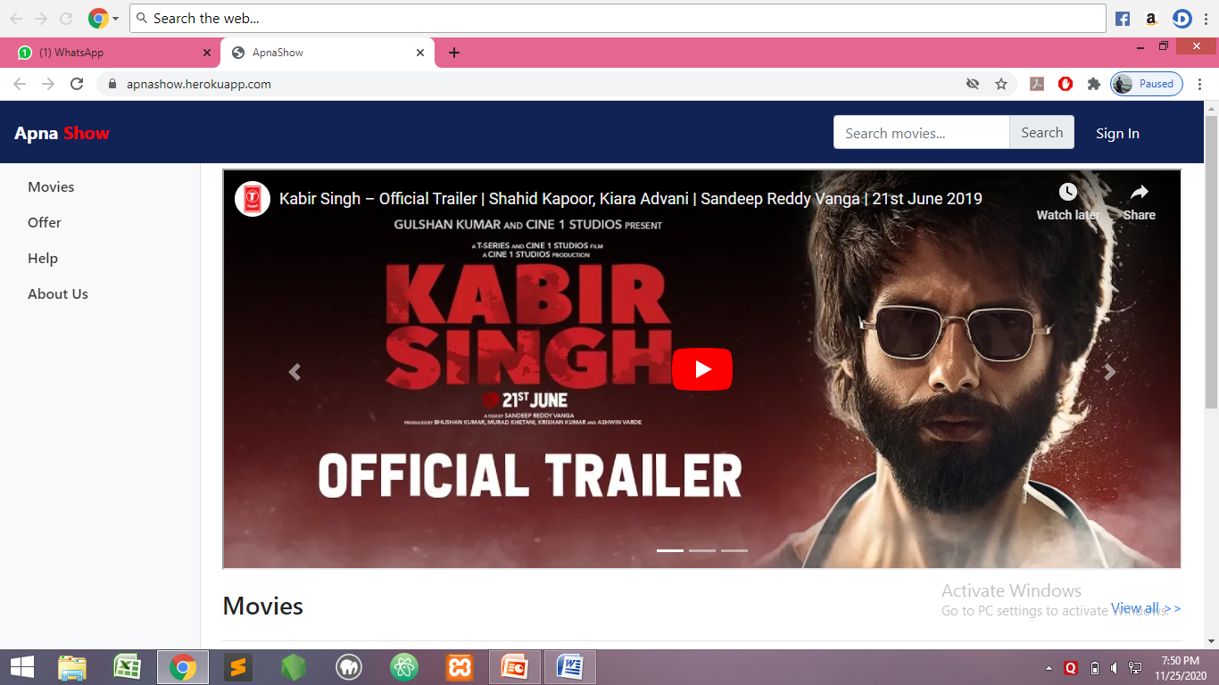

*Filter Option:* Filters the movie based on genre and language.

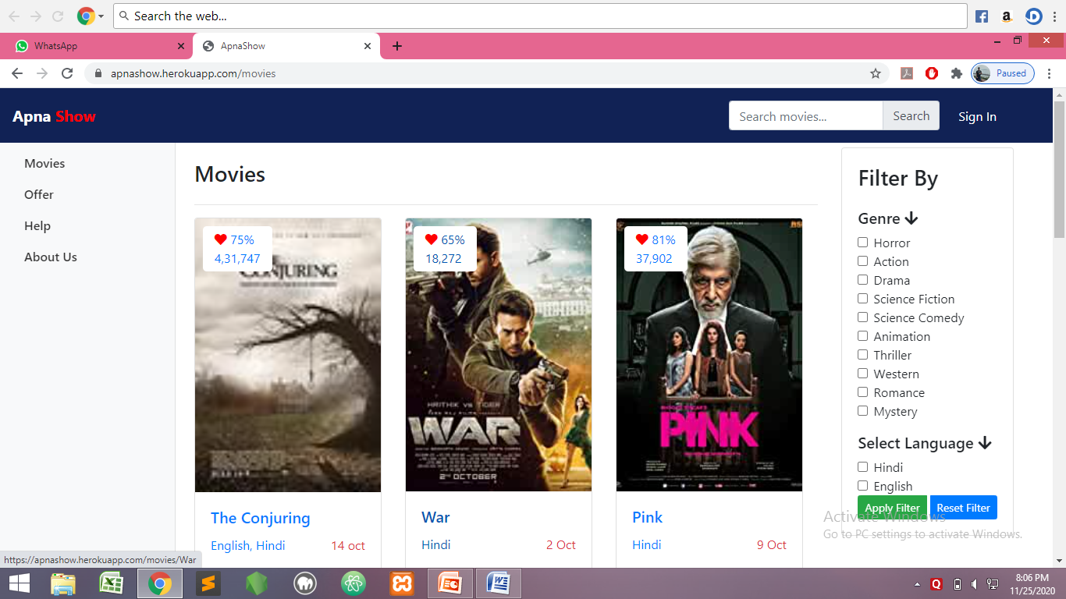

4

*SignUP/SignIN Page:* User can Signin if already have an account or can create using Signup.

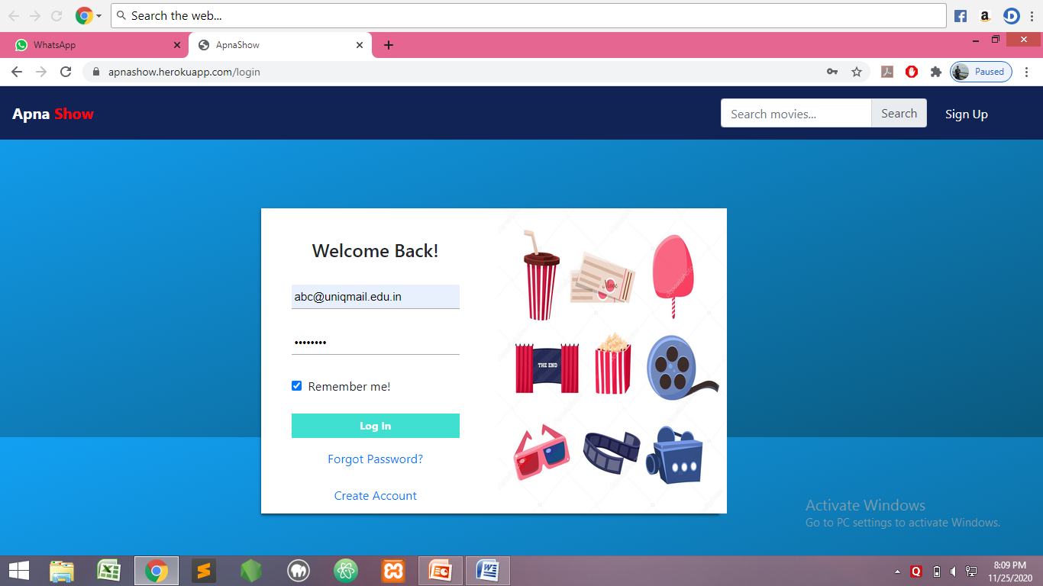

-SignUP Page-

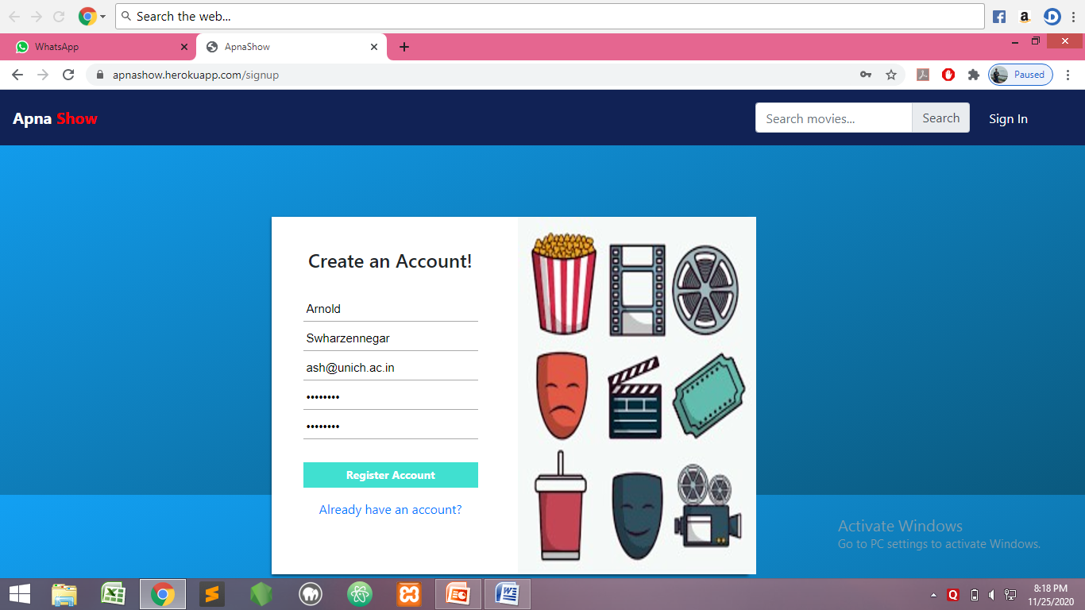

5

*Trailers:* Displays the latest video snippets.

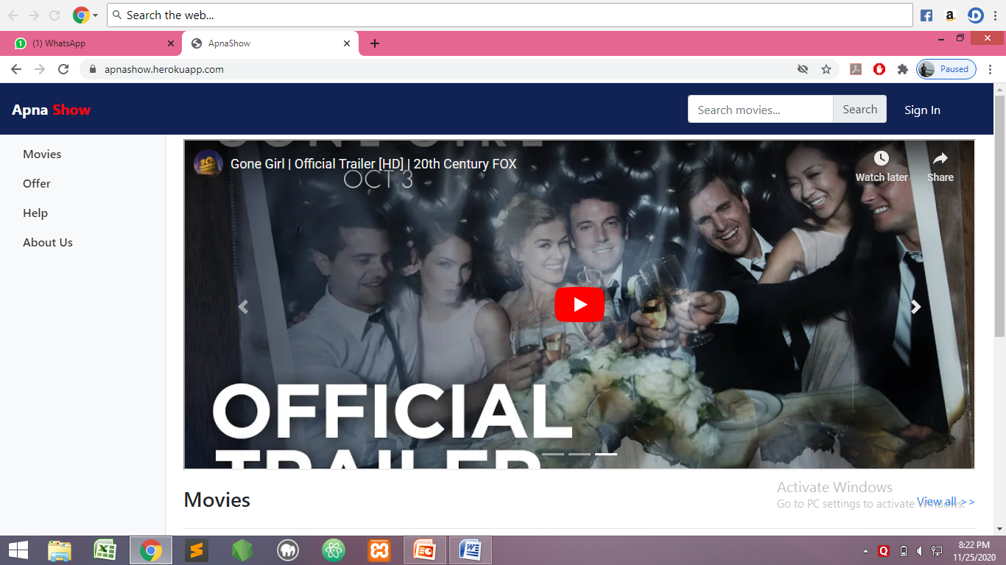

*FAQ Page:* Displays the frequently asked questions based on booking, offer availability, etc.

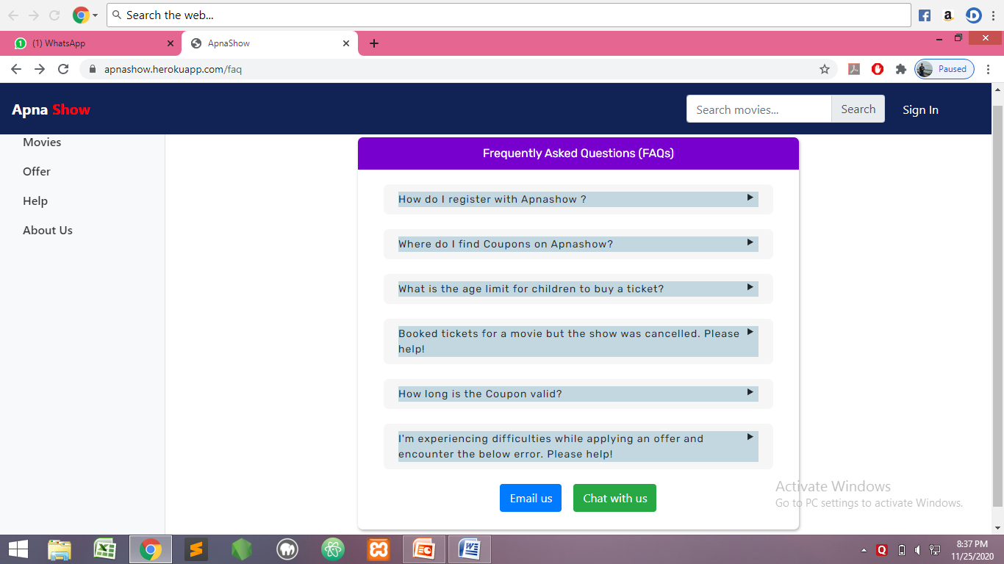

6

*Chat With Us :* This feature helps the customer to have a chat with customer care service.

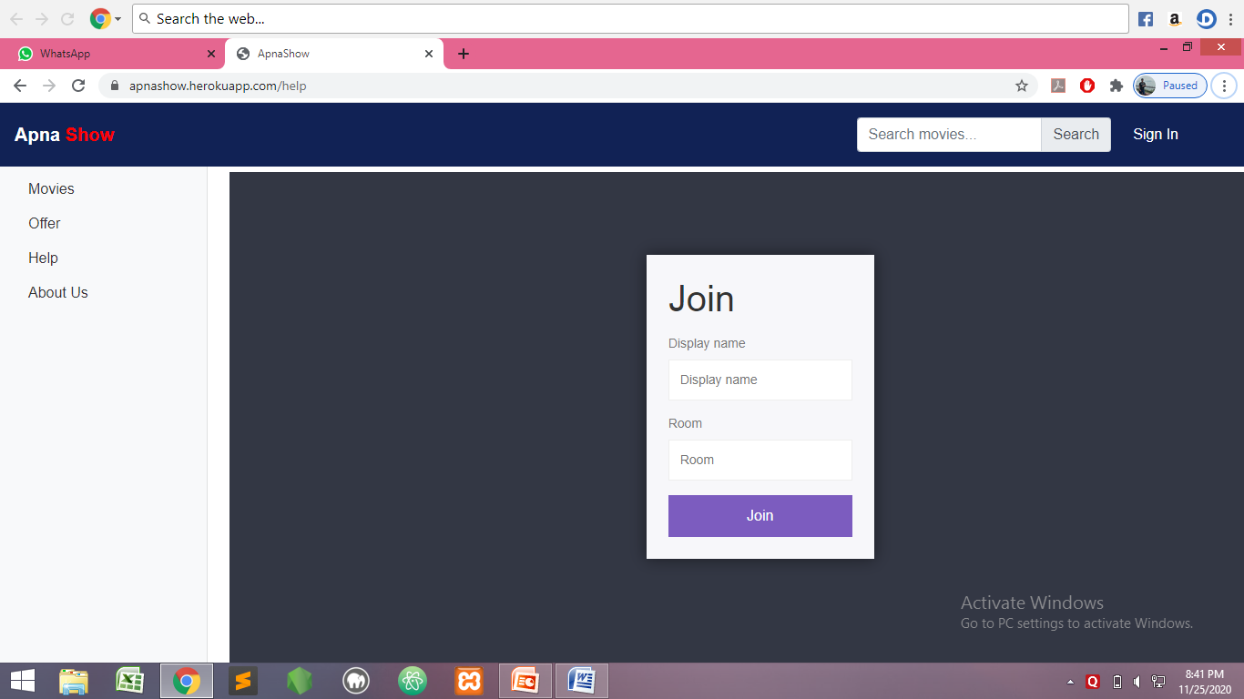

*Offer Page*: Displays the offers available for a particular payment method.

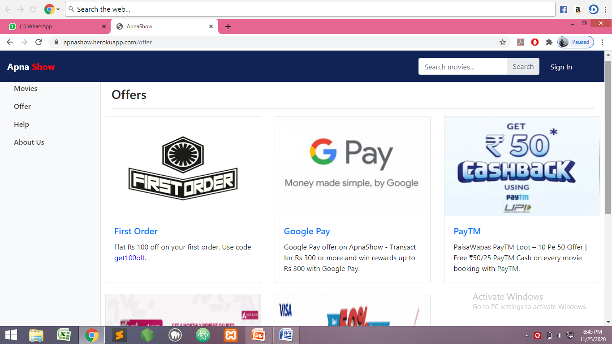

*Book Tickets:* Book tickets by selecting date, time and seat availability.

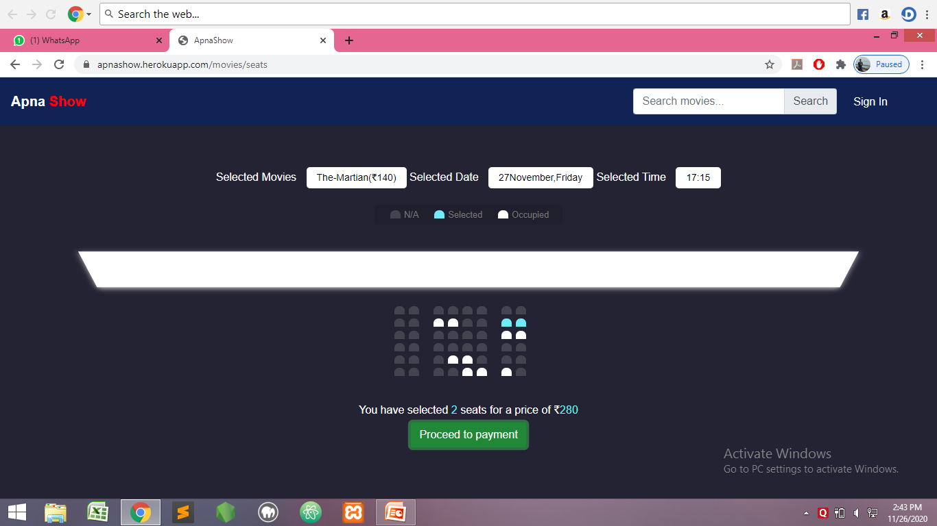

*Payment :* The customers will be able to pay online and book the tickets for their respective show.

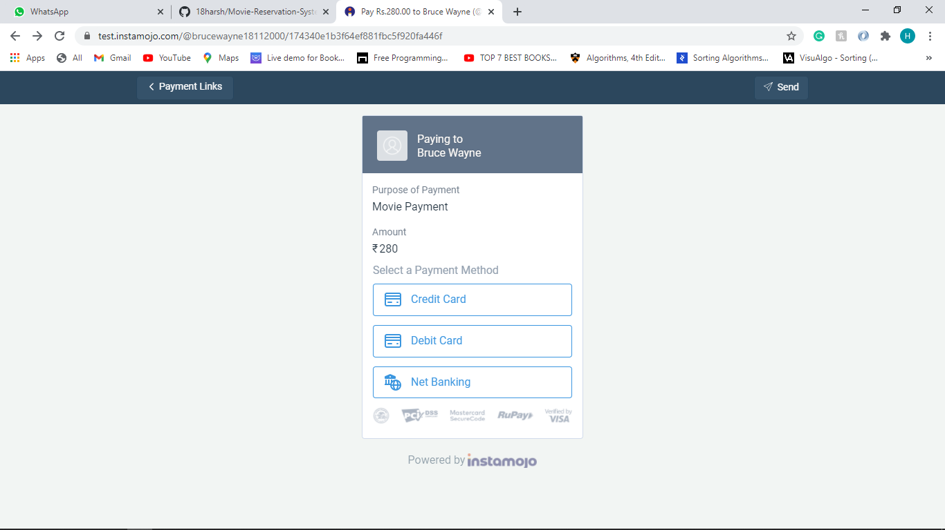

8

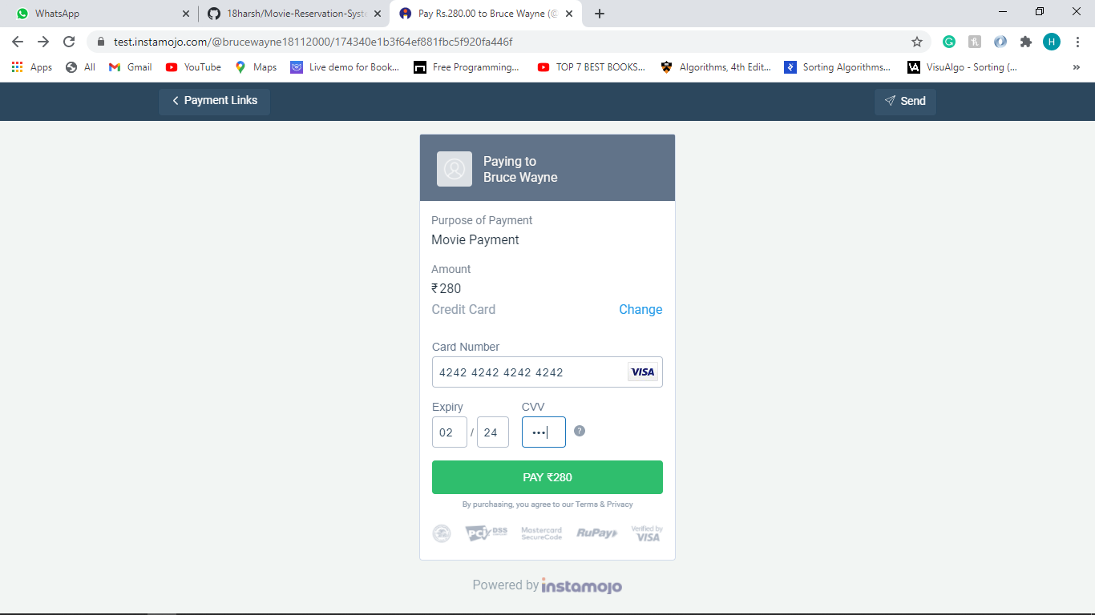

Once the payment is successful the receipt will be sent via mail to the customer.

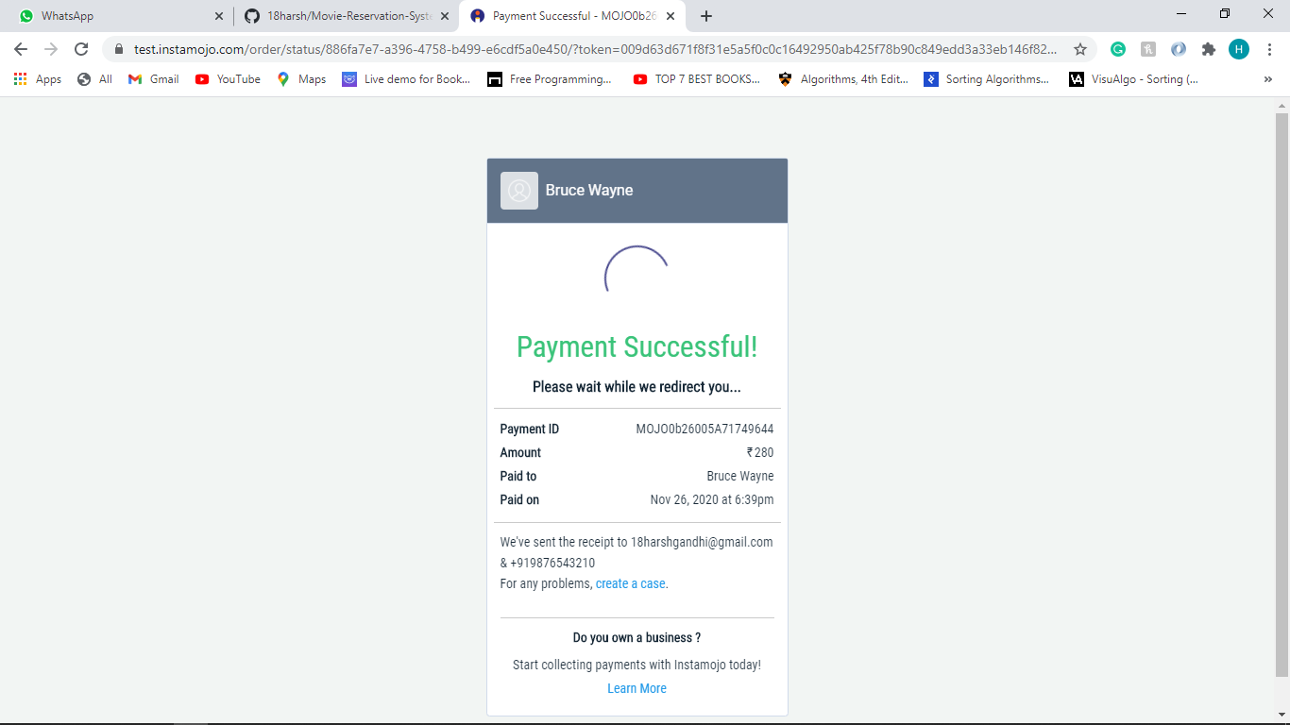

9

*Movie Database:*

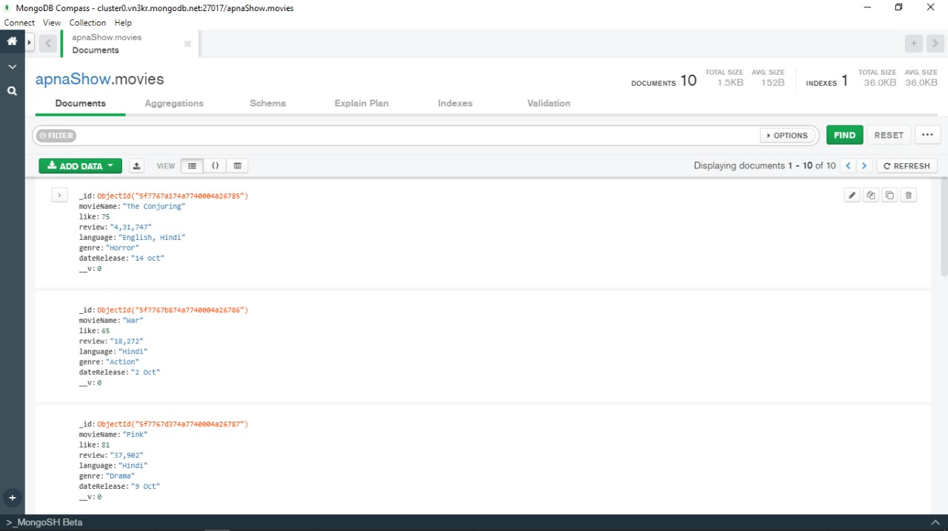

*User Database:*

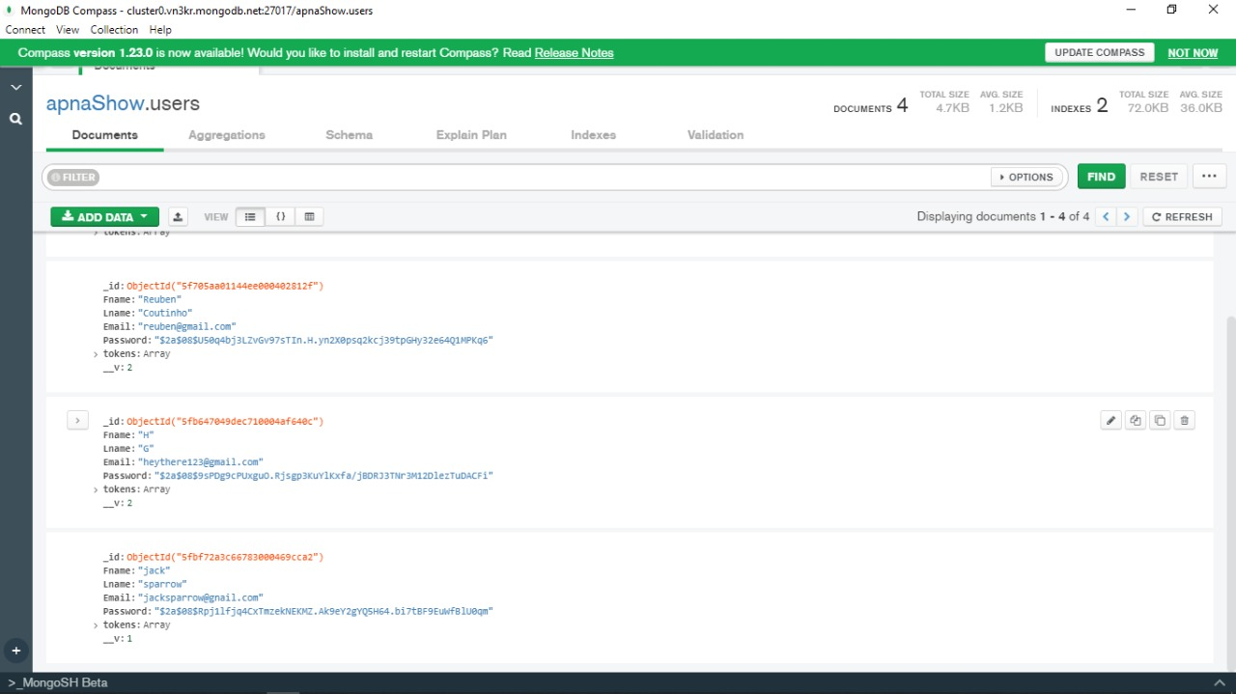

10

1. **Advantages:**

-Book according to your convenience.

-The plethora of options to choose from.

-Simple and Easy to use.

-Saves your time.

-User authentication is maintained private.

1. **Disadvantages:**

**-**You need internet access.

-Software glitches can cause you buy the same ticket twice.

-Unfortunate network loss during paying online can leave you in confusion whether you have paid or you have to.

1. **Future Scope:**

-The project Movie Booking Website(ApnaShow) is flexible enough to meet the requirements of the customers.

-Security features are implemented. No unauthorised access the package, as the security is implemented through login and password.

-It will grant more easy access.

1. **Conclusion:**

Thus, the Movie Booking Website - ApnaShow is developed and is fully functional as the mini-project for the subject Web development (WD). Using this website one can easily book tickets from around anywhere.

11